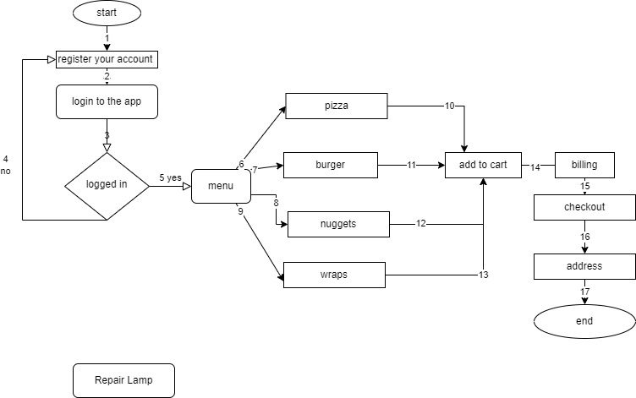

**Test groups:**

**Logged in: 1->2->3->5**

**Not logged in: 1->2->3->4**

**Pizza Add to cart: 1->2->3->5->6->10**

**burger Add to cart: 1->2->3->5->7->11**

**Nuggets Add to cart: 1->2->3->5->8->12**

**Wraps Add to cart: 1->2->3->5->9->13**

**Pizza billing: 1->2->3->5->6->10->14**

**burger billing: 1->2->3->5->7->11->14**

**Nuggets billing: 1->2->3->5->8->12->14**

**Wraps billing: 1->2->3->5->9->13->14**

**Pizza checkout: 1->2->3->5->6->10->14->15**

**burger checkout: 1->2->3->5->7->11->14->15**

**Nuggets checkout: 1->2->3->5->8->12->14->15**

**Wraps checkout: 1->2->3->5->9->13->14->15**

**Variable identification:**

**1: Quantity should be in whole numbers. Special characters and alphabets are not allowed.**

**2: Amount should be whole numbers not alphabets and characters.**

**3: Address should have alphanumeric, space, comma, hash.**

**4: Email**

**5: Password**

**6: Ccv**

**7: Credit Card Number**

**Equivalence Class Partitioning:**

***1: QUANTITY:***

**Valid:**

**Quantity>1**

**Data set: {1 ,2,7,10}**

**Invalid:**

**Negative numbers, alphabets & special characters.**

**Data set: {1 ,2,7,10, a, b, $, -2}**

***2: Amount:***

**Valid:**

**Amount>1**

**Data set: {1 ,2,7,10}**

**Invalid:**

**Negative numbers, alphabets & special characters.**

**Data set: {1 ,2,7,10, a, b, $, -2}**

***3: Address:***

**Valid:**

**Numbers, alphabets & special characters.**

**Data set: {532 a block}**

**Invalid:**

**Number<1**

**Data set: {null}**

**4: Email**

**Valid: alphanumeric, @,dot, domain**

**Data set:** [**{haroon1@gmail.com}**](mailto:%7bharoon1@gmail.com%7d)

**Invalid:**

**Number<1 & special characters other than @ and dot**

**No domain available**

**Data set{haroon-1.gmail.com}**

**5: Password**

**Valid:**

**Min 8 characters allowed**

**Alphanumerics, special characters allowed**

**Invalid:**

**Character<8**

**Null**

**6: CCv**

**Valid:**

**Only 3 characters**

**Only numbers**

**Invalid:**

**3<Character>3**

**Alphabets and special characters**

**7: Credit Card Number**

**Valid:**

**Only numbers**

**16 characters allowed**

**Invalid:**

**16<Characters>16**

**Alphabets and characters are not allowed**